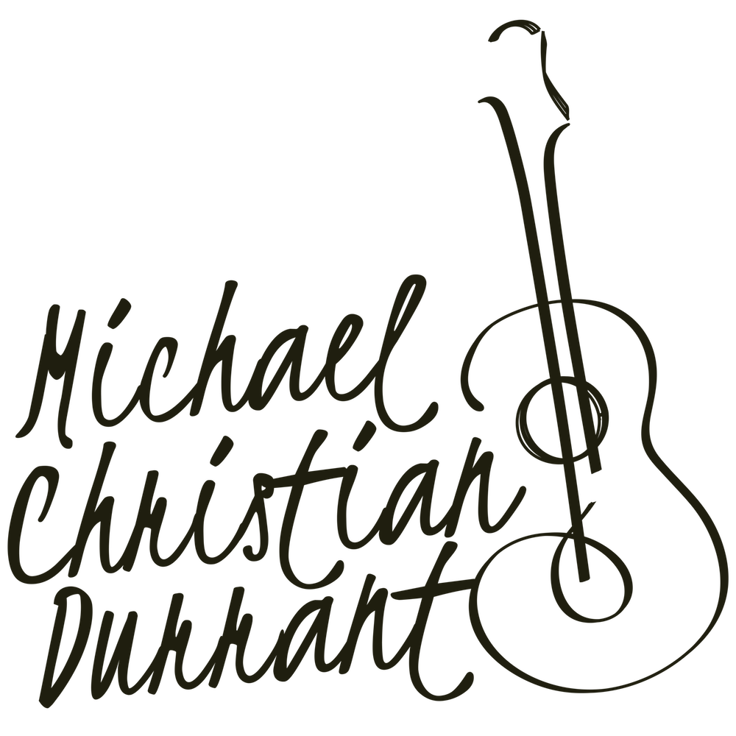

Michael Christian Durrant, Classical Guitarist
Repertoire, Concertos and Solo Recitals (2019/20 Concert Season)

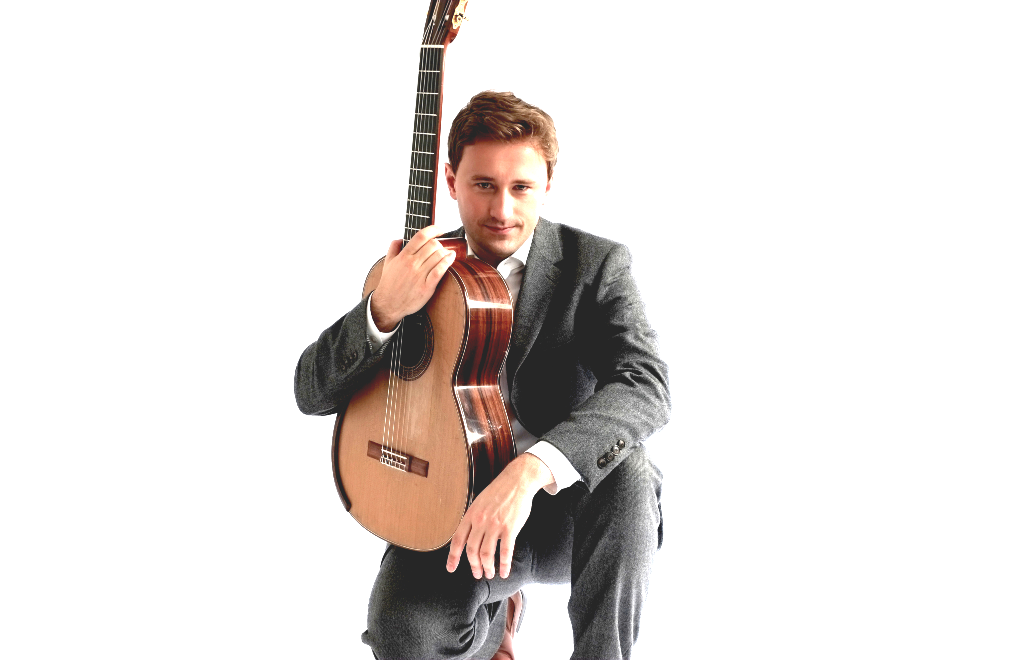

Concertos

Guitar and Orchestra

Joaquín Rodrigo (1901 – 1999):
Concierto de Aranjuez para guitarra y orquesta: 1) Allegro con spirito; 2) Adagio; 3) Allegro gentile

Fantasia para un gentilhombre para guitarra y orquesta: 1) Villano y ricercar; 2) Españoleta y fanfarria de la caballería de Nápoles; 3) Danza de las Hachas; 4) Canario

Mario Castelnuovo-Tedesco (1896 – 1968):
Concerto no. 1 in D major, Op. 99: 1) Allegretto; 2) Andantino alla romanza; 3) Ritmico e cavalleresco

Heitor Villa-Lobos (1997 – 1959):
Concerto pour guitare et petit orchestre, W501: 1) Allegro preciso – poco meno; 2) Andantino e Andante; 3) Cadenza: Quasi allegro – Andane – Quasi allegro – Poco moderato; 4) Allegro non troppo

Mauro Giuliani (1781 – 1829):
Concerto no. 1 in A major, Op. 30: 1) Allegro maestoso; 2) Andantino (Siciliano); 3) Polonaise – Allegretto

Antonio Vivaldi (1678 – 1741):
Concerto in D major, RV 93: 1) Allegro; 2) Largo; 3) Allegro

Guitar and Choir

Mario Castelnuovo-Tedesco (1896-1968):
Romancero Gitano for guitar and mixed choir, Op. 152: 1) Baladilla de los Tres Ríos; 2) La Guitarra; 3) Puñal; 4) Procesion – Paso – Saeta; 5) Memento; 6) Baile; 7) Crótalo

Solo Repertoire

Popular Classics/Arrangements:

Edward Grieg (1867 – 1907)
Morning Mood from Peer Gynt Suite, Op. 46

Claude Debussy (1862 – 1918)
Suite Bergamasque; III. Clair de Lune
Piano Prelude No. 8; La Fille Aux Cheveux De Lin

Stanley Myers (1930 – 1993)
Cavatina, theme from The Deer Hunter

Johann Pachelbel (1653 – 1706)
Canon in D

Traditional English Folk Song
Greensleeves Romanesca

Howard Blake (b. 1938)
Walking in the Air, theme from The Snowman

Léo Delibes (1836 – 1891)
Flower Duet from Lakmé

Wolfgang Amadeus Mozart (1756 – 1791)
Rondo alla Turca from Piano Sonata no. 11, K.
Andante from Piano Concerto no. 21, K. 467

Astor Piazzolla (1921 – 1992)
Libertango

Erik Satie (1866 – 1925)
Gymnopedie No. 1
Gnossienne No. 1

Anonymous
Romanza Anonímo (Jeux interdits)

Traditional Guitar Repertoire:

Fernando Sor (1778 – 1839)
Introduction and variations on a theme of Mozart, Op. 9
Moonlight étude in b minor, Op. 35, No. 22

Mauro Giuliani (1781 – 1829)
Variations on a Theme of Handel, Op. 107
Grande Ouveture, Op. 61

Agustín Barrios Mangoré (1885 – 1944)
La Catedral (The Cathedral): 1) Preludio Saudade, 2) Andante Religioso, 3) Allegro Solemne
Vidalita con variaciones (inédita)
Vals, Op. 8 no. 4

Johann Sebastian Bach (1685 – 1750)
Chaconne, BWV 1004
Prelude, Fugue and Allegro, BWV 998
Adagio and Fugue, BWV 1000
Two Minuets from the notebook of Anna Magdalena

Heitor Villa-Lobos (1887 – 1959)
Five Preludes:
Prelude no. 1 in E minor
Prelude no. 2 in E major
Prelude no. 3 in A minor
Prelude no. 4 in E minor
Prelude no. 5 in D major

William Walton (1902 – 1983)
Bagatelles no. 2 and 3 from Five Bagatelles

Yuquijiro Yocoh (b. 1925)
Sakura, theme and variations on a Japanese folk song

Benjamin Britten (1913 – 1976)
Nocturnal after John Dowland, Op. 70

Spanish Repertoire:

Isaac Albéniz (1860 – 1909)
Granada (Serenata), No. 1 from Suite Española
Sevilla (Sevillana), No. 3 from Suite Española
Asturias (Leyenda), No. 5 from Suite Española

Enrique Granados (1867 – 1916)
Danza Española Op. 37, No. 2 (Oriental)
Danza Española Op. 37, No. 5 (Andaluza)

Bartolomé Calatayud (1882 – 1973)
Boceto Andaluz (Andalucían Sketch)
Simpatia
Bolero

Francisco Tárrega (1852 – 1909)
Capricho Arabé (Serenata)
Lagrima (Prelude)
Recuerdos de la Alhambra (Memories of the Alhambra)
Gran Vals
Maria (Gavoto)
Sueño (Mazurka)

Joaquín Rodrigo (1901 – 1999)
Adagio from Concierto de Aranjuez
Por los campos de España: En Los Trigales (In the Wheat Fields)
Invocación y Danza (Homenaje a Manuel de Falla)

Chamber Music Ensembles:

- Guitar and String Quartet with the Sacconi Quartet
- Guitar and Piano with Nico de Villiers
- Guitar and Violin with Ines Delgado

Programme proposals available upon request.

